Civil Engineering Insight Studio

1. INTRODUCTION:

1.1 Project Overview:
Civil Engineering Insight Studio is a smart digital platform designed to help civil engineers, students, and construction professionals analyze, plan, and manage construction projects efficiently. It provides tools for project visualization, cost estimation, structural analysis insights, and real-time monitoring to improve decision-making in civil engineering projects.

1.2 Purpose:
The purpose of this project is to provide an integrated platform for civil engineering project analysis, help engineers and students visualize construction data and project progress, improve planning and cost estimation, and reduce manual work through digital tools.

2. IDEATION PHASE:

2.1 Problem Statement:
Civil engineering projects often face issues such as poor planning, cost overruns, lack of real-time monitoring, and inefficient data management. Traditional methods rely on manual calculations and scattered tools, leading to delays and errors. This project aims to design a digital system that helps civil engineers manage and analyze projects efficiently.
Problem Statement Report: Click Here
2.2 Empathy Map Canvas:
Users: Civil engineers, students, contractors, project managers.
Thinks: Needs accurate calculations and planning tools.
Feels: Frustrated with manual work and errors.
Says: Wants easy monitoring and cost estimation.
Does: Uses multiple software and manual methods.
Pain Points: Time-consuming calculations, poor tracking.
Gains: Efficient planning and time saving.
Empathy Map Canvas Report: Click Here
2.3 Brainstorming:
Ideas include digital dashboard, cost estimation tools, structural design insights, timeline tracking, and data visualization.
Brainstorming Report: Click Here

3. REQUIREMENT ANALYSIS:
3.1 Customer Journey Map:
User logs in → Creates project → Inputs details → System analyzes → Dashboard shows insights → User monitors progress.
Customer Journey Map Report: Click Here
3.2 Solution Requirement:
Functional: Login, project management, cost estimation, dashboard, reports.
Non-functional: User-friendly, secure, fast, reliable.
Solution Requirement Report: Click Here
3.3 Data Flow Diagram:
User inputs data → System processes → Database stores → Reports generated.
Data Flow Diagram Report: Click Here
3.4 Technology Stack:
Frontend: HTML, CSS, JavaScript
Backend: Python/Node.js
Database: MySQL
Visualization: Chart.js/Power BI
Technology Stack Report: Click Here
4. PROJECT DESIGN:
4.1 Problem Solution Fit:
The system reduces manual errors and improves project planning using automation.
Problem Solution Fit Report: Click Here
4.2 Proposed Solution:
A web-based platform for cost estimation, monitoring, analytics, and report generation.
Proposed Solution Report: Click Here
4.3 Solution Architecture:
User Interface → Backend → Database → Reports
Solution Architecture Report: Click Here

5. PROJECT PLANNING & SCHEDULING:
Requirement gathering → Design → Development → Testing → Deployment
PROJECT PLANNING & SCHEDULING Report: Click Here

6. FUNCTIONAL AND PERFORMANCE TESTING:
- Testing login,
- calculations,
- dashboard speed,
- multi-user support,
- report generation.
- FUNCTIONAL AND PERFORMANCE TESTING Reports: Click Here
- : Click Here

7. RESULTS:
- Login page,
- dashboard,
- estimation page,
- report page outputs.
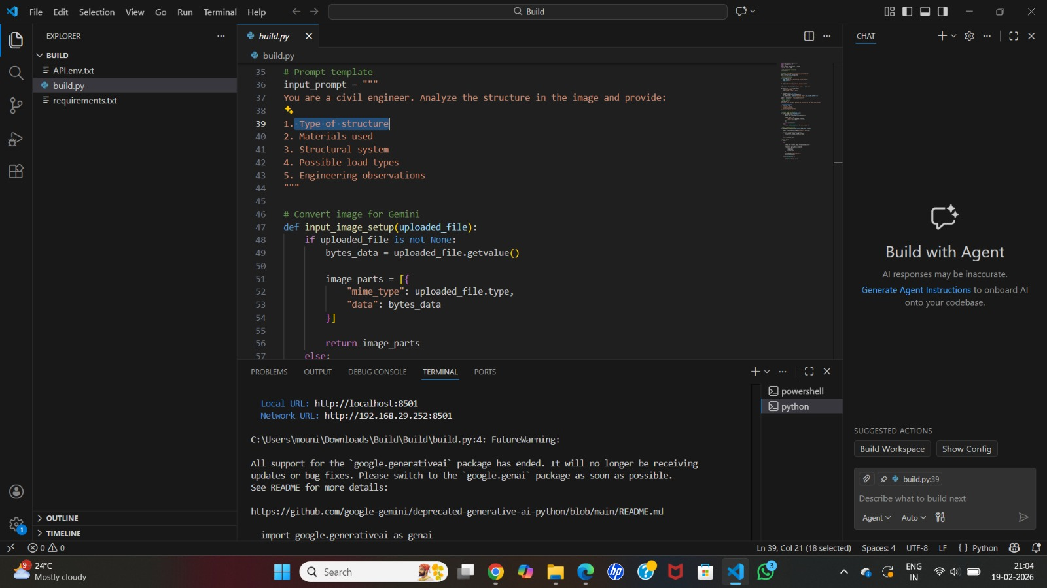

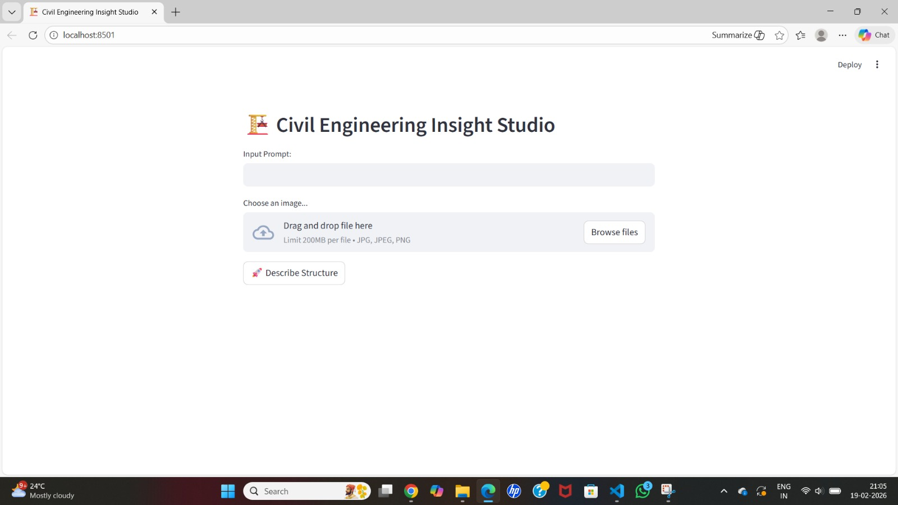

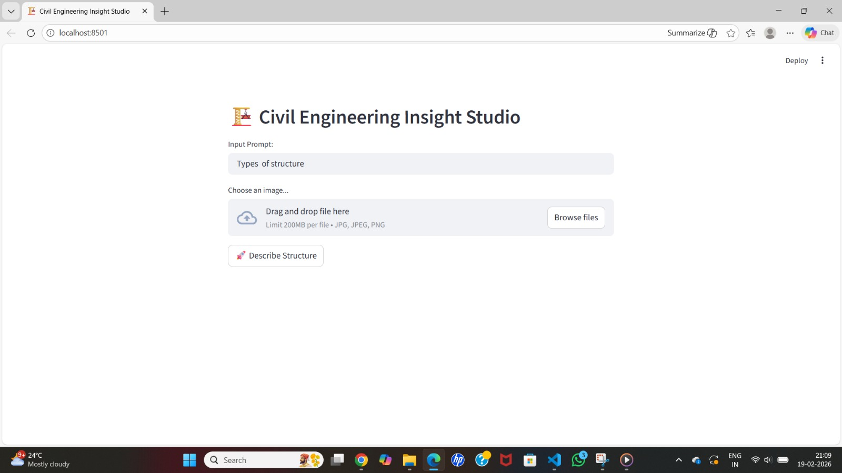

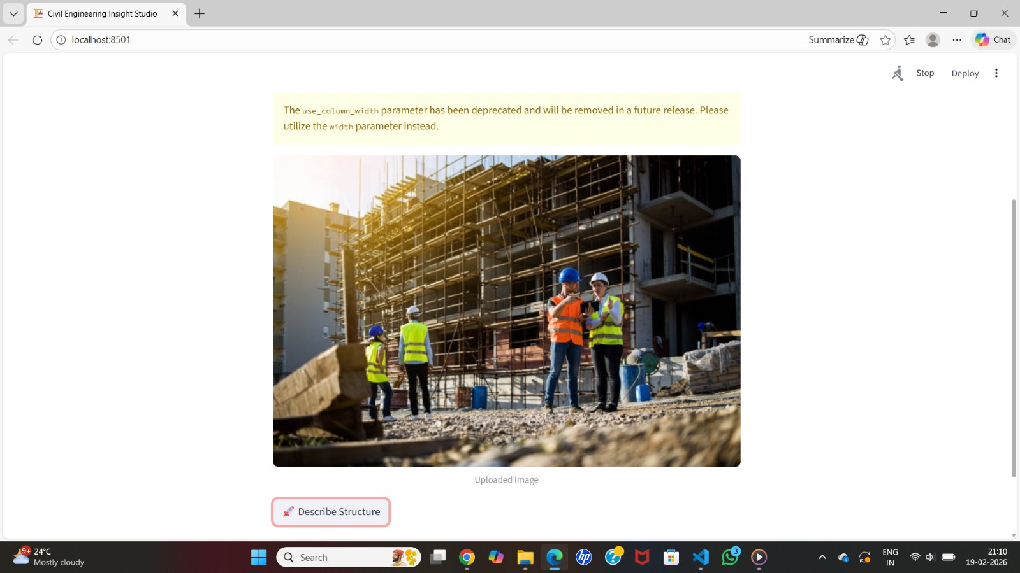

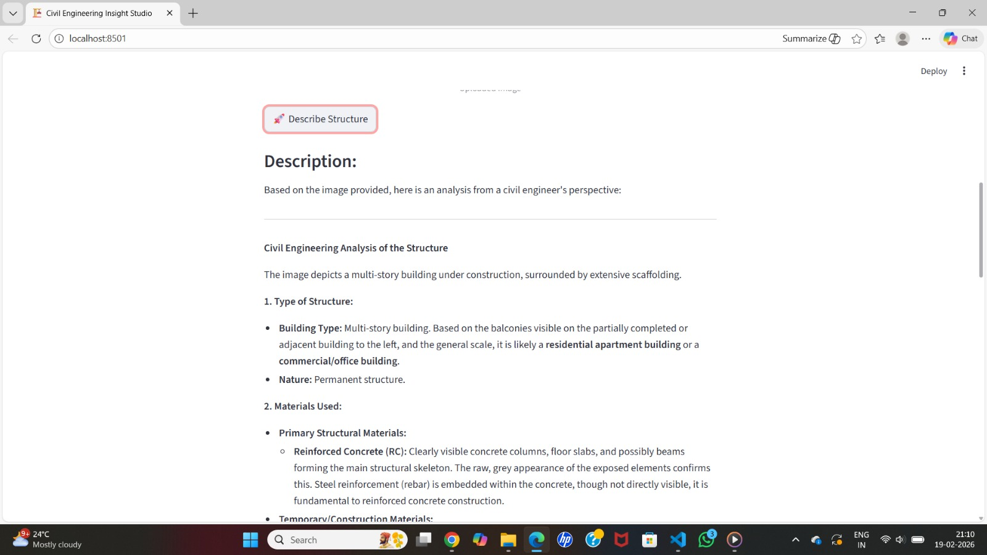

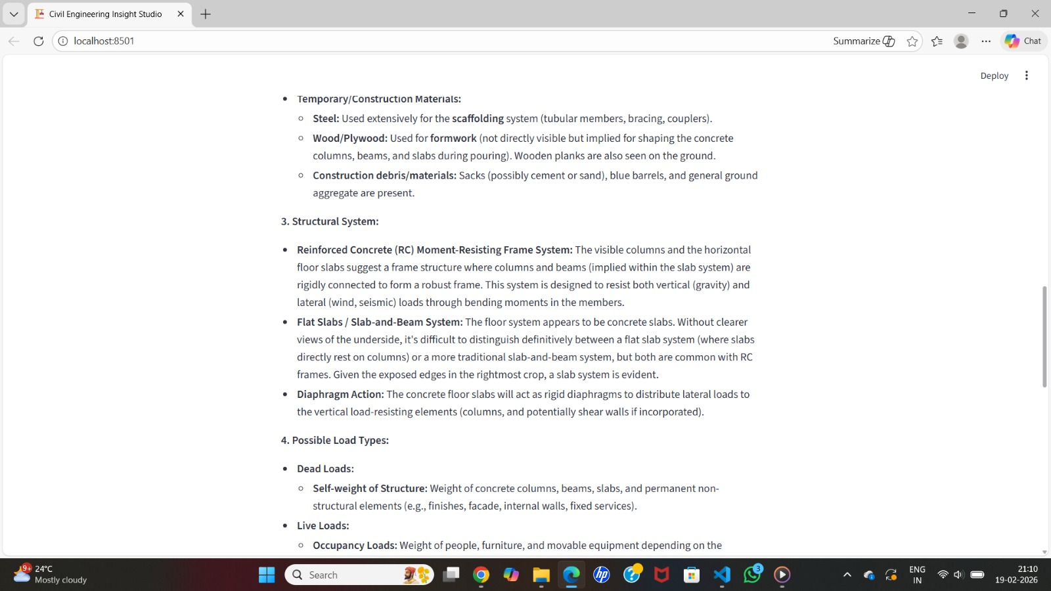

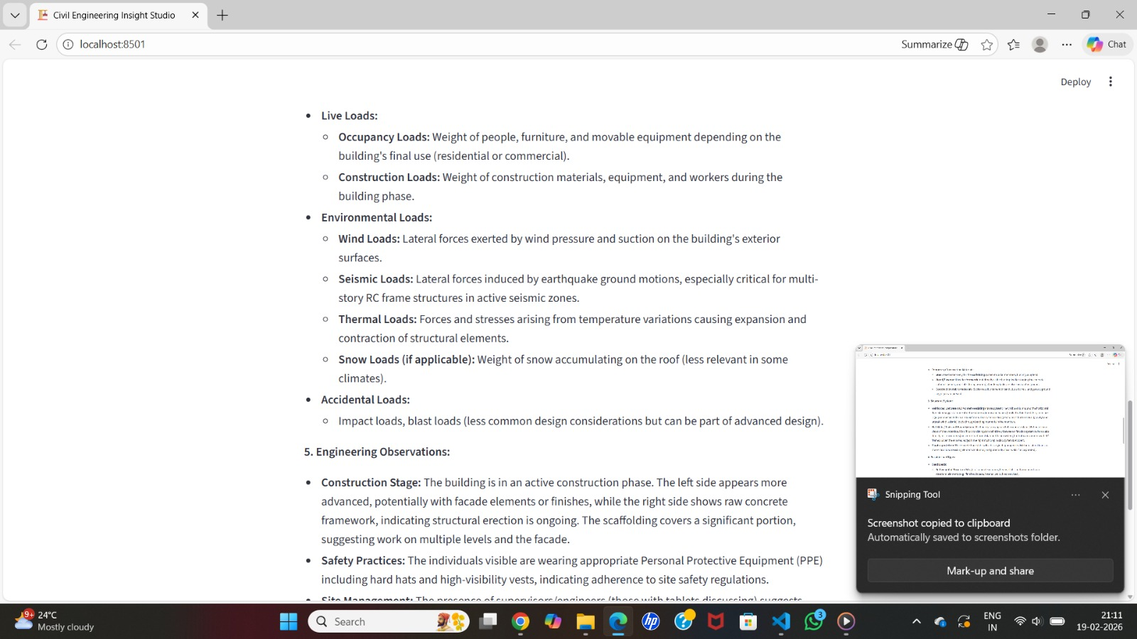

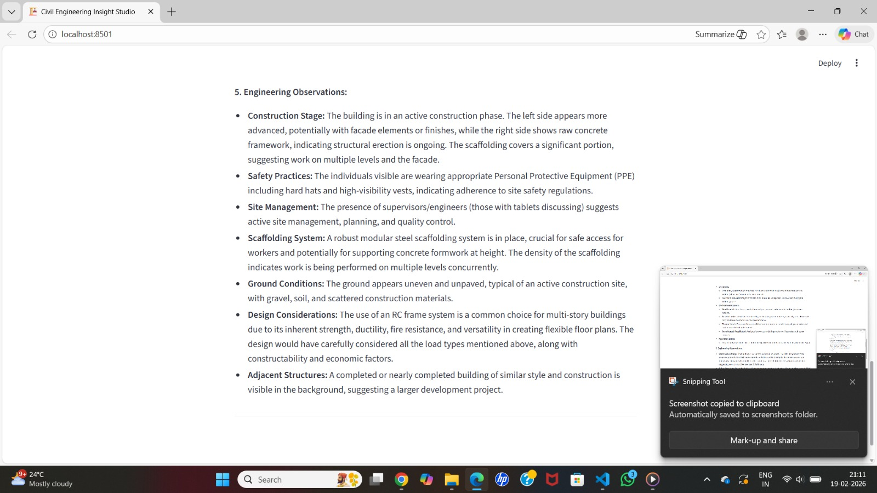

8. ADVANTAGES & DISADVANTAGES:
Advantages:
- Saves time,
- accurate,
- user-friendly.
Disadvantages:
- Needs internet,
- initial setup.

9. CONCLUSION:
This project simplifies civil engineering planning and improves efficiency and accuracy.

10. FUTURE SCOPE:
- AI integration
- mobile app
- 3D visualization
- cloud storage
- IoT monitoring.

11. APPENDIX:
Source Code Report: Click Here
GitHub link: Click Here
Project Demo Link: Click Here

